
www.arabgreekchamber.gr
BUSINESS NEWS & EVENTS
UPDATES 19/06/2009

SYRIA – ΣΥΡΙΑ  INVESTMENT OPPURTUNITY:  THE INDUSTRIAL CITY IN HASSIA – SYRIA  The Industrial City in Hassia Occupies a distinctive position on the Global. Territorial and Syrian economic map as an evolutional and strategically project which can support the national economy, advance the comprehensive development process and ensure work for many people in order to create the appropriate climate for investment as an incubator for all kinds of Industrial, Residential, Commercial and Recreational projects.  The Investment’s Services and Facilities  - The investor can obtain the industrial license during one hour.  - The land is free but the investor should pay 40% of the infrastructure’s cost when he gets the license.  - Investors of the industrial city have the priority to obtain loans from banks.  - Exempting the investors from all the fees of the production’s materials and equipments according to the investment law.  - The Arab and foreign investors can get their own proceeds after they pay the fees and they can rent and own lands.  - The non- Syrian investor according to the investment law can get industrial license to work and he can stay in Syria with his family until the project is finished.  - The investors can get work licenses and residences for the non-Syrian workers.  - The investor can provide his project with the required equipments easily.  - There is tax minimization according to the investment law for the establishments in the industrial city in Hassia and other according to the worker’s number in the project.  The Investment in the Industrial City in Hassia, Why ?  - An important geographical location in the center of Syria which is in its turn is the center of the World.  - The city includes all kinds of social cultural, professional Services.  - The city includes a free zone that responds to all the requirements of the investors and also includes all the activities.  - Dry port where all custom’s formalities are handled there.  - Wide consumption markets specially for what the city will offer in future in Iraq’s building.  - Handcraft zone that includes (villas- houses- banks- restaurants- medical centers- malls – worshiping centers- exhibitions city- hospitals) .  Infrastructure and Equipments  - The construction and development of the industrial city in Hassia is a distinctive which work present a complementary infrastructure that fits all different economical activities.  - A complementary network of roads.  - A developed network for electricity distribution and conduction to all the divisions and suit power to each project.  - Good water net for industrial and residential use.  - A modern communication net.  - Good soil that doesn’t need any treatment.  - Industrial and healthy sewerage treatment stations.  - Textile industries zone  - Nutritive industries zone  - Engineering industries zone  - Chemical industries zone  - Handicraft zone  - Sport zone  - Recreational zone  - Residential zone  - Free zone  - Train station  - Dry port  For further information:  Syria – Homs : Tel.: +963 31 2229454 / Fax.: +963 31 22183191  Syria- Hassia: Tel.: +963 31 5360007/8 / Fax.: +963 31 5360003  E-mail. info@ic-homs.sy / customer@ic-homs.sy  www.ic-homs.sy  GREECE- ΕΛΛΑΔΑ  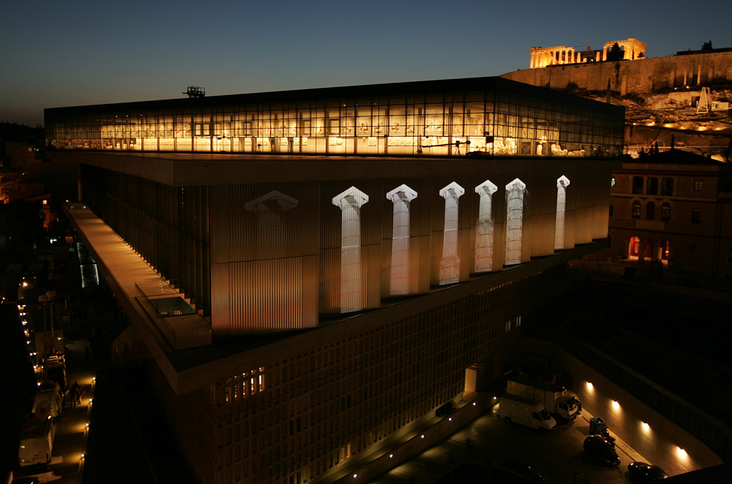  New Acropolis Museum officially inaugurated  The New Acropolis Museum was officially inaugurated on Saturday evening during a nationally televised and web-broadcast ceremony that brought together Greece's political leadership and scores of international dignitaries, boosting hopes that the purpose-built museum's opening will mark the "reverse countdown" for the long-sought return of the Parthenon Marbles.  In one of the most poignant moments of the evening, Prof. Dimitris Pantermalis, the director of the new state-of-the-art facility, pointed to numerous mutilated sculptures on display in the third-storey Parthenon Hall, sculptures whose other half is found at the British Museum in London. Instead white-coloured plaster replicas depict the missing friezes in the New Acropolis Museum.  Pantermalis personally gave a guided tour of the museum to international dignitaries, including EU Commission President Jose Manuel Barroso and UNESCO Director-General Koïchiro Matsuura, who addressed the ceremony, as well as to Greece's leadership.  "Today, the whole world can see, all together, the most significant sculptures of the Parthenon. Some are missing.  Now is the time to heal the monument's wounds with the return of the marbles to where they belong ... their natural setting," Greek President Karolos Papoulias said in addressing the international audience and television viewers across the country.  Prime Minister Costas Karamanlis emphasized that the new 130-million-euro museum belongs to all of humanity and forms part of the world's cultural heritage.  "In the sacred hill of the Acropolis the world views the forms that ecumenical and eternal ideals take. In the New Acropolis Museum the world can now ascertain these forms, these ideals, reuniting them and allowing them to regain their radiance ... Welcome to a Greece of civilization and history; together we are inaugurating a museum for the supreme monument of the Classical civilization: the Acropolis Museum," Karamanlis said, while again referring to his namesake and uncle, Greek statesman Constantine Karamanlis, along with iconic Greek actress and culture minister Melina Mercouri, as protagonists in the decades-long campaign to build the new museum.  On his part, Greek Culture Minister Antonis Samaras opened his address by expressing optimism that "the (pieces) that are not here today, those that were separated and carted off 207 years ago will return. They will certainly return; the Parthenon and its sculptures were the victims of plunder. This crime can, today, can be corrected. The museum serves as the moral force to invite them back; to reunite them," he stressed.  For more information visit the website:  www.newacropolismuseum.gr  GREECE – ΕΛΛΑΔΑ  Athens Stock Exchange (ASE) opening: Decline  Equity prices were declining at the opening of trade on Monday on the Athens Stock Exchange (ASE), with the basic share price index down 0.89 percent, standing at 2,213.97 points at 10:45 a.m., and turnover at 8.5 million euros.  Individual sector indices were moving mostly downward, with the biggest losses in Raw Materials, down 2.21 percent; Public Utilities, down 1.89 percent; and Health, down 1.86 percent.  The biggest gains were in Mass Media, up 0.86 percent; Travel & Recreation, up 0.71 percent; and Oil & Gas, up 0.22 percent.  The FTSE/ASE 20 index for blue chip and heavily traded stocks was down 0.83 percent, the FTSE/ASE MID 40 index was down 1.63 percent, and the FTSE/ASE-80 small cap index was down 0.55 percent.  Of the stocks moved, 25 were up, 74 were down, and 19 were unchanged.  Source.: Athens News Agency  GREECE – ΕΛΛΑΔΑ  Gov't: Another 5% of OTE to DT  The government intends to activate a provision of the strategic contract signed between Hellenic Telecoms (OTE S.A.) and Deutsche Telecom (DT) allowing the Greek state to sell-off another 5 pct of the utility to DT for the predetermined price of 27.5 euros per share. Economy and Finance Minister Yiannis Papathanassiou announced the decision to DT CEO Rene Obermann on Thursday, during a meeting held at the ministry.  Papathanassiou stated afterwards that the strategic agreement, signed last year and ratified in Parliament, provides that the German telecoms giant is obligated to purchase 5 pct of the OTE S.A. shares with the specific price per share if requested by the Greek government. The move will not affect the Greek state's rights as regards control over OTE.  The OTE share price, based on the Athens Stock Exchange (ASE) closing prices on Wednesday, stands at 11.77 euros -- meaning that the Greek state will collect 674 million euros, compared to 288.5 million euros it would have received based on the current ASE share price (roughly 11.7 euros per share). The Greek state's extra gain will be 388.5 million euros, Papathanassiou concluded. PASOK reaction  Conversely, a main opposition spokeswoman on economic policy sharply criticized the development, charging that the government is selling-off more of the state's shares in OTE simply to raise cash.  FOR MORE INFORMATION ABOUT FAIRS EXHIBITIONS, CONFERENCES, SYMPOSIUM & MEETINGS IN ALL ARAB COUNTRIES  YOU MAY VISIT OUR WEBSITE:  www.arabgreekchamber.gr | GREECE- ΕΛΛΑΔΑ  «Εκ παραδρομής στο προηγούμενο τεύχος γράφτηκε από λάθος ότι η παρακάτω έκθεση θα γίνει από 07-11/06/2009 . Ζητούμε συγνώμη για το λάθος αυτό.»  POSIDONIA / 07-11/June/2010- Athens.  As always, the Posidonia exhibition will be strongly attended by the Greek shipowners, as well as owners from most other maritime nations. Exhibitors will also meet the technical and operations management attending the show, representing not only Greek owners but also the international organizations which together create the largest commercial meeting place in the shipping calendar. Planning for the future, they will be keen to find the latest equipment, technologies, financial and service offering.  Organizers: Posidonia Exhibitions S.A. / 4-6 Efplias street, 18537 Piraeus, Greece/ Tel.: +30 210 428 3608/ Fax.: +30 210 4283610 /  E-mail.posidonia@posidonia-events.com  www.posidonia-events.com  IRAQ- ΙΡΑΚ  Από την πρεσβεία του Ιράκ μας έστειλαν το παρακάτω έγγραφο προς ενημέρωσή σας .  Η Πρεσβεία της Δημοκρατίας του Ιράκ απευθύνει τους χαιρετισμούς της προς το Αραβο-Ελληνικό Επιμελητήριο Εμπορίου & Αναπτύξεως και ζητά από το Επιμελητήριο να ενημερώσει τις εταιρείες παραγωγής φαρμάκων και ιατρικών ειδών να σπεύσουν να καταγράψουν τα φαρμακευτικά τους προϊόντα στο αρμόδιο τμήμα του Υπουργείου Υγείας.  Για περισσότερες πληροφορίες παρακαλώ επικοινωνήσετε με την πρεσβεία του Ιράκ.  Τηλ. 210 6722330/ Fax.: 210-6717185/  E-mail.iraqath@otenet.gr  KUWAIT – ΚΟΥΒΕΙΤ  Από την Πρεσβεία του Κουβέιτ στην Αθήνα μας έστειλαν τον οδηγό “Directory of Kuwaiti Exporting Factories” . Όποιος ενδιαφέρεται για οποιαδήποτε πληροφορία από τον οδηγό αυτό θα μπορεί να επικοινωνεί με το Επιμελητήριο , ώστε να του στείλουμε τις πληροφορίες που θέλει.  Επίσης μπορείτε να επισκεφθείτε την ιστοσελίδα: www.kuwaitexport.gov.kw.  LEBANON- ΛΙΒΑΝΟΣ  “Back to Basics in Post-Crisis Strategies” is this year’s title for the International Arab Banking Summit for 2009 , which the Union of Arab Banks will be organizing, in cooperation with the European Banking Federation, the World Union of Arab Bankers and with various regional Arab and International institutions, in London, at the Waldorf Hilton, during the period 25-26/6/2009 .  For further information please visit the website: www.uabonline.org .  GREECE- ΕΛΛΑΔΑ  PHILOXENIA 09 –  25^{η} Διεθνής Έκθεση Τουρισμού / 29/10 – 1/11/2009  Θεσσαλονίκη .  Ποια είναι τα οφέλη από τη συμμετοχή σας στην έκθεση.  - Ή Προβολή της επιχείρησής σας διεθνώς.  - Η άμεση επικοινωνία με κορυφαίες επιχειρήσεις του κλάδου.  - Η διεύρυνση της πελατειακής σας βάσης.  - Τα προκαθορισμένα ραντεβού ΜΟΝΟ των εκθετών , με προσκεκλημένους από την HELEXPO ξένους Tour Operators.  Για περισσότερες πληροφορίες :  www.philoxenia.travel  25th International Tourism Exhibition /  29/10- 1/11/2009 , Thessaloniki, Greece  The benefits of your participation in the exhibition.  - The international promotion of your enterprise.  - The direct communication with top companies of your sector.  - Enrichment of your customer data base.  - Prearranged meetings EXCLUSIVELY for exhibitors with international Tour Operators that are invited by HELEXPO.  For further information please visit the  Website: www.philoxenia.travel  UNITED KINGDOM- ΗΝΩΜΕΝΟ ΒΑΣΙΛΕΙΟ  ARAB-BRITISH ECONOMIC FORUM 2009  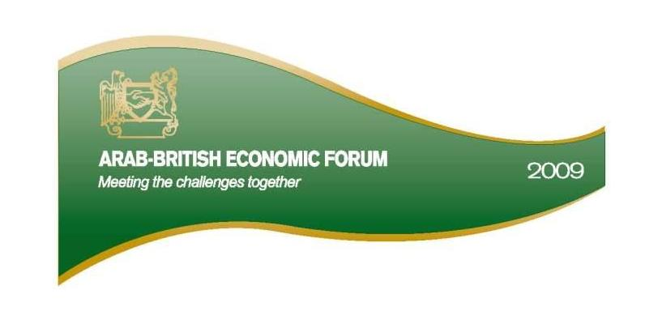  The Arab British Economic Forum (ABEF) will be held from 27-28 October 2009 at the Inter Continental Hotel Park Lane, London. It is supported by the Arab League, Arab and British Chambers of Commerce, UKTI and British Expertise. Participants will assess the commercial opportunities available to Arab and British businesses Meeting the Challenges Together.  Arab-British Chamber of Commerce  www.abcc.org.uk  Further information is available at www.abef.org.uk  LIBYA- ΛΙΒΥΗ  Eleventh Mediterranean Petroleum Conference and Exhibition / 23-25 February 2010 , Tripoli, Libya  The eleventh Mediterranean Petroleum Conference and Exhibition (MPC 2010), is an international forum of experts and scientists to identify and exchange ideas and views regarding recent developments to on improving oil recovery, on oil field technology, environmental impact  assessment and economic aspects of the oil and gas industry.  Main Topics:  - Exploration  - Drilling  - Improved recovery of mature oil field  - Oil and gas transportation  - Oil and gas processing and refining.  - Human recourses development challenges & competencies  - Production and reservoir management  - Production related problems and environmental impacts  - Reservoir optimization and management  - Offshore oil and gas technology  - Petroleum information technology  - Safety in oil and gas industry  - Global oil and gas supply and demand  - Gas technologies  - Down stream oil industry  - Corrosion phenomena, inhibitors and protective coatings.  Organizers: International Energy Foundation (IEF) & National Oil Corporation (NOC) in Cooperation with Faculty of Engineering, Al Fateh University, Libyan Petroleum Institute(LPI), United Nation Development Program (UNDP).  For further information: Tel.+218 21 3331832/33/34/ Fax.: +218 21 3331831/  E-mail.training@ief.ly/ www.ief.ly  GREECE – ΕΛΛΑΔΑ  Athens Newspaper Headlines  The Monday edition of Athens' dailies at a glance  The grand inauguration of the New Acropolis Museum on Saturday evening in Athens, the Greek people's resounding demand for the Parthenon Marbles' repatriation and speculation of early general elections dominated the headlines on Monday in Athens' newspapers.  ADESMEFTOS TYPOS: "The demand for the Parthenon Marbles' repatriation is international - Foreign newspapers and media support Greece's demand".  APOGEVMATINI: "Open letter to British Prime Minister Gordon Brown for the repatriation of the Parthenon Marbles".  AVRIANI: "Danger of collapse of the political system - Opinion poll indicates that the majority of the people reject both mainstream political parties (ruling New Democracy and main opposition PASOK)".  ELEFTHERI ORA: "The Marbles call the Marbles - International demand for Parthenon Marbles repatriation".  ELEFTHEROTYPIA: "Citizens may 'finger' tax evaders" - Economy Ministry, in its official website, calls on the citizens to become snitches".  ESTIA: "The new Museum is the golden opportunity for Athens to become an international centre of attraction".  ETHNOS: "Prime Minister Costas Karamanlis' two 'emergency exits' - Government members' recommendations for early elections and government reshuffle are contradictory".  TA NEA: "Here's the theft! The 'amputated' frieze causes shock".  VRADYNI: "The Marbles' silent protest - Emotion and awe before the 'amputated' Parthenon frieze".  IRAQ – ΙΡΑΚ  Από την Πρεσβεία του Ιράκ στην Αθήνα μας ενημέρωσαν για τα παρακάτω θέματα:  -Προκήρυξη διαγωνισμού προς όλες τις φαρμακευτικές και ιατρικές εταιρείες σχετικά με ταινίες για τον σακχαρώδη διαβήτη για τις ανάγκες του 2010.  Για περισσότερες πληροφορίες μπορείτε να επισκεφθείτε την ιστοσελίδα:  www.kim-moh.net Καταλυτική ημερομηνία είναι η 1/7/2009 .  -Επίσης προκήρυξη διαγωνισμού για την ίδρυση παγκοσμίου βιβλιοθήκης στη Βαγδάτη και την Ακαδημία της στις δύο γλώσσες Αραβική και Αγγλική  Για περισσότερα επισκεφθείτε την ιστοσελίδα : www.baytuthikmairaq.org  Για οποιαδήποτε πρόσθετη πληροφορία παρακαλώ επικοινωνήστε με την Πρεσβεία του Ιράκ στην Αθήνα στο τηλ.  210-6722330 / Fax.: 210-6717185/  E-mail.atnemb@iraqmofamail.net

