ECC “Sokolniki”, Moscow, Russia
Early bird discount of 10%* available until December 1st
(payment should be made according the deadline)

15 – 18 September, 2016 (hereinafter – the “Show”)
Opening hours: 15 – 17 September - 11:00-19:00; 18 September- 11:00-18:00

Please fill in, sign and return to the Organizer:
"Messe Frankfurt RUS" Ltd. (hereinafter – the “Organiser”)
Leningradsky Prospect, 39 build. 80
125167, Moscow, Russia
Tel.: + 7 (495) 649 87 75
Fax: + 7 (495) 649 87 85
E-Mail: Elena.de.Lange@messefrankfurt.com
Sofia.Bolshakova@russia.messefrankfurt.com
Alexandra.Yurchenko@russia.messefrankfurt.com

Deadline for signing up - July 22, 2016
To be filled in by the Organiser:
Client’s No | Stand size, sq.m | Stand’s No

Contract - Application form
The Parties have agreed that the current Contract-Application form can be signed by the Parties by means of the Contract-Application copy exchange via fax or via e-mail. The procedure is as follows: the Exhibitor signs the Contract-Application form and sends it to the Organiser by fax or by e-mail. Upon the receipt of the signed Contract-Application form from the Exhibitor, the Organiser signs it and sends it to the Exhibitor by fax or by e-mail on short notice. The fax or the e-mail copy of the Contract-Application form received by each Party shall be regarded as original. The originals of all the documents shall be handed in on the first day of the Show.

1. Exhibitor data
The information given in paragraph 1 may be used in the Show catalogue as official information about your company if the Organiser does not receive any other information in due time.
1.1 Exhibitor

Name of your Company

Contact person(s)

Street

City Postal code Country

Phone FORMTEXT / FORMTEXT / Fax / FORMTEXT /
Country code City /Area code Number Country code City /Area code Number

E-mail (actual) Website

1.2 Sub-exhibiting
Compulsory fee for each sub-exhibitor (including services indicated in Para 7) – 250 Euro + 18 % VAT

Name of your Company

Contact person(s)

Street

City Postal code Country

Phone FORMTEXT / FORMTEXT / Fax / FORMTEXT /
Country code City /Area code Number Country code City /Area code Number

E-mail (actual) Website

In case more than one sub-exhibitor participates at a joint stand, it is necessary to submit the list of sub-exhibitors together with the Contract-Application Form indicating contact information on all sub-exhibitors (company name, address, telephone, e-mail, contact person).
2. Product groups (please indicate the percentage in all the boxes applicable)
The information given in paragraph 2 may be used in the Show catalogue as official information about your company if the Organiser does not receive any other information in due time

% | 01 | Pianos, grand pianos, historical keyboard instruments, accessories | % | 08 | Acoustic guitars, other plucked instruments, accessories
% | 02 | Organs, keyboards, synthesizers, accessories | % | 09 | Harmonicas, accessories
% | 03 | Electric guitars and electric bass guitars, accessories | % | 10 | Stringed instruments, accessories
% | 04 | Sheet music / trade media / service enterprises | % | 11 | DJ equipment, accessories
% | 05 | Percussion instruments, electronic drums, accessories | % | 12 | Sound-recording, audio / video, software
% | 06 | Woodwind instruments, accessories | % | 13 | Label, artists, online, events & concerts
% | 07 | Brass instruments, accessories | % | 14 | Accessories general

3. Brands & Trade Marks (please, indicate in the box below)

Exhibitor’s liability:
By signing this Contract-Application form the Exhibitor confirms his status of processing all rights according to all requirements of the legislation of the Russian Federation with regard to the use of intellectual property rights and accepts full responsibility in case of Third party claims of infringement by the Exhibitor the intellectual property rights.
Settlement of any dispute is at Exhibitor’s own responsibility and expense.

4. Your company’s activities (please tick all the boxes applicable)

01 Production 03 Representative office 05 Press

02 Trade 04 Association 06 Other (please specify)

5. Raw space rental (minimum size – 9 square meters)

Price per 1 square meter*: The stand size: square meters
a booth with 1 or 2 open sides: 135 Euro + 18 % VAT
a booth with 3 open sides: 142 Euro + 18 % VAT
a booth with 4 open sides: 146 Euro + 18 % VAT
a “double-decker” booth: 203 Euro + 18 % VAT
The price of the stand rental includes:
- raw space rental,
- aisle cleaning,
- pavilion security at nighttime.

Please, note that electric power supply is NOT INCLUDED in the above space rental price and is to be ordered as an additional service. Electric power supply prices can be found in the exhibitor manual that will be sent to you separately.

6. Stand requirements

Standard construction:

Price per 1 square meter: 60 Euro + 18 % VAT

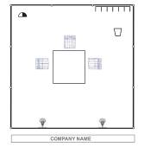

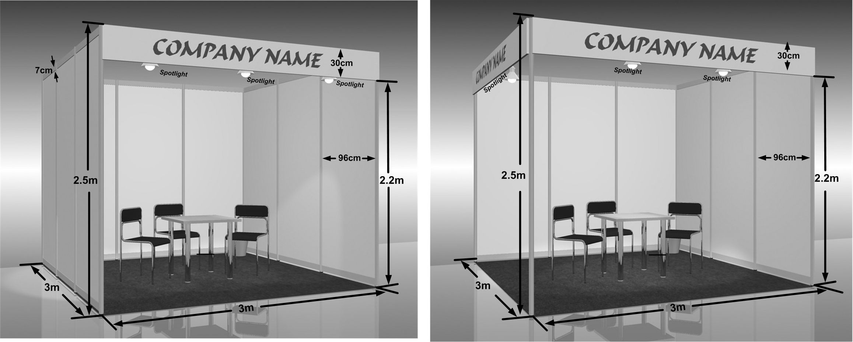

Standard package includes:
- stand construction and dismantling,
- white wall panels (2.5 meter high),
- wall-to-wall carpet (grey),
- a fascia board with the company name and the booth number,
- halogen lights (the number depends on the stand size),
- tables and chairs (the number depends on the stand size),
- sockets (the number depends on the stand size),
- waste paper baskets (the number depends on the stand size)

Please tick the box if you need a Standard package:

Please, note that electric power supply is NOT INCLUDED in the Standard and Standard+ booth construction and is to be ordered as an additional service.

7. Obligatory registration fee: 250 Euro + 18 % VAT

Registration fee includes:

- Information about the company in official on-line catalogue ( in English and in Russian)
- Information about the company in the official show guide,
- exhibitor badges ,
- invitation tickets that can be distributed to the clients,
- The invitations for the exhibitors’ welcome reception for 2 persons.

Excerpt from General event conditions
General conditions of participation in the Show  The detailed information concerning the terms of participation in the Show can be found in the “General Event Conditions” that can be downloaded from the Show web-site http://gec.messefrankfurt.ru  1.1 Organiser  (1) The organiser of the Fair is OOO Messe Frankfurt RUS (the "Organiser")  Leningradsky Prospekt 39 bld 80  125167 Moscow, Russian Federation  Tel: + 7 495 649 87 75; Fax: + 7 495 649 87 85  1.2 Registration  (1) To be admitted to the Fair, an Exhibitor should submit a fully completed Contract-Application form for the Fair. The Exhibitor shall affix his/her legally binding signature to the Contract-Application form and send the  form to the Organiser prior to the deadline for application indicated in the Contract-Application form. The registration is valid for the time of the Fair indicated in the Contract-Application form. The submission of a Contract-Application form does not constitute grounds to demand that the applicant be admitted to the Fair. Fax copies of the Contract-Application forms are accepted by the Organiser and are equally valid for both parties. The original of the Contract-Application form is to be handed to the Organiser either by post or directly at the fair.  1.4 Assignment of stands and changes in their size  (1) Stands shall be assigned in accordance with technical criteria relevant for the Fair. Regardless of any proposals concerning the stand location and included in his/her Contract-Application form, the Exhibitor has no right to demand that a stand of a specific size or located in a particular place be assigned thereto.  1.7 Entry in the Fair catalogue  (2) The Exhibitor undertakes to apply for publication of the entry in the catalogue. In order to ensure the completeness of the catalogue, the Organiser shall be entitled to include the entry on the Exhibitor in the catalogue at the expense of the Exhibitor based on the information from Application form or available to the Organiser or information contained in the | previous Fair’s catalogue without being liable for the accuracy of such entry, if the Exhibitor fails to submit his/her application to the Organiser at least three months prior to the beginning of the Fair.  1.6 Terms of payment; unilateral refusal to perform the contract in case of non-payment and insolvency  (2) Along with the confirmation for the stand the Exhibitor usually receives an invoice indicating the stand fee. The value added tax is added to all stated prices, as provided for by law. Russian Exhibitors shall pay invoices in Russian rubles. Foreign Exhibitors shall make all payments in Euros.  50% of the invoiced amount is due upon the receipt of the invoice; the remaining 50% of the invoice total is due at least 2.5 months prior to the beginning of the Fair, unless otherwise set out by the Organiser in the blank Contract-Application form. If after the due date of payment the Exhibitor applies for and is allocated a bigger exhibition area than that requested in his/her original application from, any additional stand fee shall become immediately due and payable. Invoices for additional equipment and services immediately due and payable. The payment shall be made in such a manner that the respective amount would be credited to the Organizer’ accounts without any additional costs thereto and in due time. All the banking commissions are to be paid by the exponent (participant).  1.9 Use of the stand; recovery of damages and liability for nonparticipation; contractual penalty; unilateral refusal to perform the contract  (3) In the event an Exhibitor that has been Registered and admitted for participation cancels its participation in the Exhibition, for whatever reason, the Exhibitor shall be liable for cancellation of this Contract as follows: | (3.1.) If the Exhibitor cancels this Contract not because of the Organizer’s failure to duly perform its obligations under this Contract more than 4 months before the Exhibition date, it shall pay the registration fee.  (3.2.) If the Exhibitor cancels this Contract not because of the Organizer’s failure to duly perform its obligations under this Contract between 4 and 2.5 months before the Exhibition date, it shall pay 50% of the amount of the invoice issued to it under the Application Form.  (3.3.) If the Exhibitor cancels this Contract not because of the Organizer’s failure to duly perform its obligations under this Contract less than 2.5 months before the Exhibition date, it shall pay 100% of the amount of the invoice issued to it under the Application Form.  (4) The above provision shall also apply if the assigned stand fails to be occupied by 6 p.m. on the day immediately preceding the opening day of the Fair or is fully or partially vacated before the end of the Fair, or there is no personnel present at the stand, or no registered and admitted exhibits are displayed on the stand.  (5) In any case the Exhibitor shall be liable for payment of the full amount of the stand fee, which shall not affect the Organizer’ duty to mitigate any respective losses incurred in connection with the exhibition organization for the area assigned to the Exhibitor.  (6) If any of the above obligations is violated, the Organizer shall be entitled to deny the Exhibitor admission to any future Fairs. The  Exhibitor may not claim damages in connection with the foregoing.  (7) The Organizer has the right to refuse the Participation of the company that has not paid the stand rental fee and\or has any debts from the previous exhibitions in its reasonable discretion

The Exhibitor’s representative authorized to sign financial documents:
We hereby acknowledge our acquaintance with the “General Event Conditions” and our acceptance of the terms detailed therein and in this Contract-Application form. We accept these terms as an integral part of the agreement.
Exhibitor’s liability: By signing this Contract-Application form the Exhibitor confirms his status of processing all rights according to all requirements of the legislation of the Russian Federation with regard to the use of intellectual property rights and accepts full responsibility in case of Third party claims of infringement by the Exhibitor the intellectual property rights. Settlement of any dispute is at Exhibitor’s own responsibility and expense.

Position _____________________________________ Name ____________________________________________________
Date ________________________________ Signature and common seal _________________________________________
The authorised representative of the Organiser:
We hereby acknowledge acceptance of the application for exhibiting at NAMM Musikmesse Russia 2016.

Position _____________________________________ Name ___________________________________________________
Date ________________________________ Signature and common seal _________________________________________

* the Organizer reserves the right to change the prices of participation if the market situation changes considerably
* all discounts are granted to the Exhibitor provided that the Exhibitor complies with the terms of Payment (see Para 1.6 (2) )

