
BUYER APPLICATION FORM

PERSONAL & COMPANY INFORMATION (Please complete ALL fields in capital letters):
Company Name: | (Please attach/add your business card here)
Name: | (Please attach/add your business card here)
Job Title: | (Please attach/add your business card here)
Country: | (Please attach/add your business card here)
Tel: Fax: | (Please attach/add your business card here)
E-mail: | (Please attach/add your business card here)
Web: | (Please attach/add your business card here)
COMPANY PROFILE (please tick ALL that apply):
Importer Exporter Processing Factory Manufacturer Wholesaler Retailer
Buying Group Association / Institution Agent Distributor Supplier / Vendor University

Branch /Dealer / Shop Consultancy Project Service Technical Service Public

E-commerce Franchising Other/………………………………………………………..(Please Specify)

INDUSTRY / COMPANY BUSINESS (please tick ALL that apply):
Lighting Electric Project Management Electric Equipment Municipalities
Highway Ministry Governorship Other (please specify.......................)
If your company is a retailer, how many shops/branches do you have? In your country: ……... shops Abroad: …..…. shops
Please list the brands you represent: 1:...................................... 2:........................................ 3:........................................
How many employees do you have in your company? ….................................................................................................….
How many countries do you cover? ....................................................................................................................................
Revenue (last year): ……….............……………… USD Revenue growth (last year/year before): ……...............................…… %
Please make a summary of your existing business activities in your country:
..................................................................................................................................................................................................
Please list your primary objectives for visiting the fair:
.............................................................................................................................................................................................
INTERESTED FIELD OF ACTIVITY (please tick ALL that apply):
Outdoor Lighting Indoor Lighting Decorative Lighting LED Technologies Building Automation Systems
Lighting Accessories and Components Electrical Building Installation Materials and Accessories Lighting Design
Other (please specify....................................................................................................)
Please complete this form and send by email to the attention of Mrs. Rabia Alga!
Organizer: UBM ISTANBUL 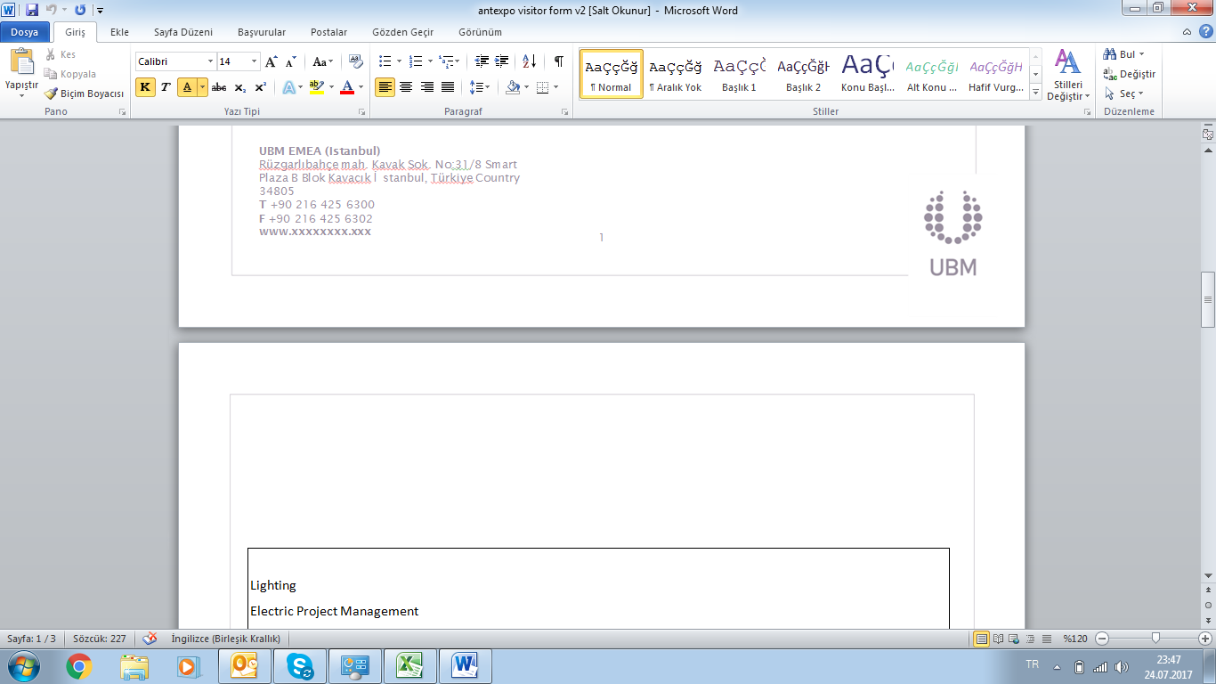    Int'l Marketing Partner: AntExpo | Mrs. Rabia Alga  Tel: +90 216 541 0390 Fax: +90 216 541 0389  E-mail: rabia@antexpo.net Web: www.antexpo.com.tr  Web: http://www.istanbullight.com/

