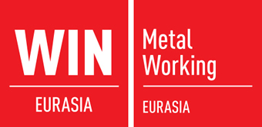
World of Industry Metal Working
International Machine Components and Metal Working Fair
www.win-metalworking.com
Istanbul 11-14.02.2016

World of Industry Welding
International Joining, Welding and Cutting Technologies Fair
www.win-metalworking.com
Istanbul 11-14.02.2016

World of Industry Surface Treatment
International Surface Treatment Technologies Fair
www.win-metalworking.com
Istanbul 11-14.02.2016

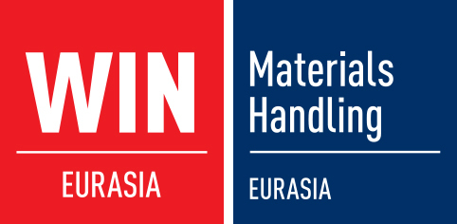
World of Industry Materials Handling
International Materials Handling and Logistics Fair
www.win-automation.com
Istanbul17-20.03.2016

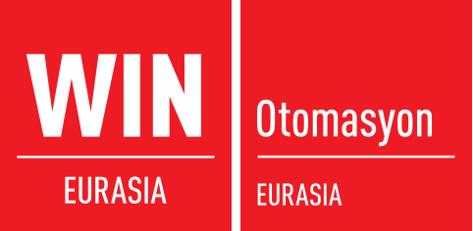
World of Industry Otomasyon
International Industrial Automation Fair
www.win-automation.com
Istanbul 17-20.03.2016

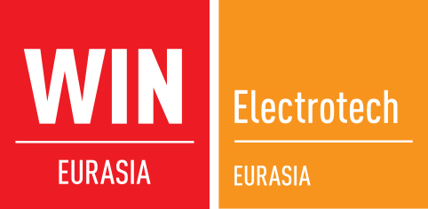
World of Industry Electrotech
International Energy, Electric and Electronic Technologies Fair
www.win-automation.com
Istanbul 17-20.03.2016

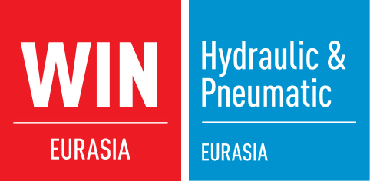
World of Industry Hydraulic & Pneumatic
International Fluid Power Technologies Fair
www.win-automation.com
Istanbul 17-20.03.2016

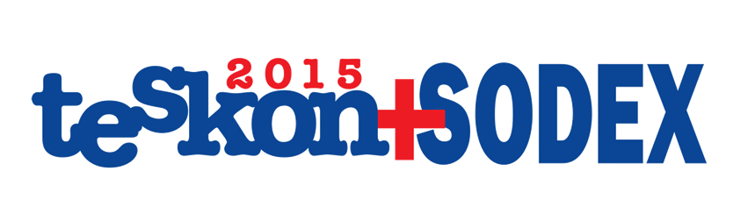
TESKON - SODEX
HVAC&R and Installation Exhibiton
www.teskonsodex.com
Istanbul 08-11.04.2015

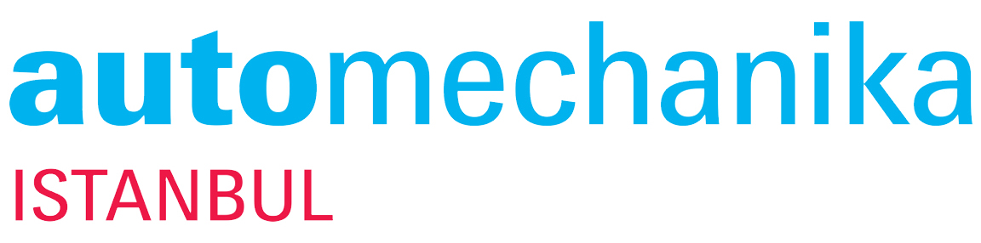
Automechanika ISTANBUL
International Trade Fairs for Automotive Manufacturing, Distribution & Repair
www.automechanika.com.tr
Istanbul 07-10.04.2016

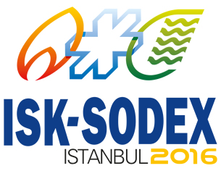
ISK - SODEX
International Trade Fairs for Sanitary and Heating
Ventilating and Air-Condition (HVAC)
www.sodex.com.tr
Istanbul 04-07.05.2016

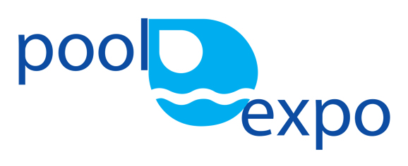
Pool Expo
Swimming Pools, SPA, Sauna and Equipments Exhibition
www.poolexpo.org
Istanbul 04-07.05.2016

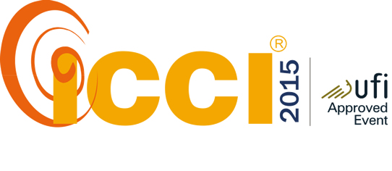
ICCI
International Energy & Environment Fair and Conference
www.icci.com.tr
Istanbul 27-29.04.2016

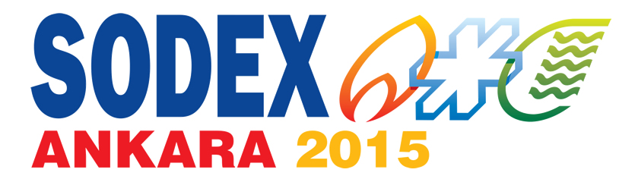
SODEX ANKARA
HVAC&R Exhibiton
www.sodexankara.com
08-11.04.2015

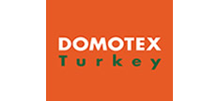
Domotex TURKEY
Trade Fair for Carpet and Flooring
www.domotexturkey.com
Istanbul 23-26.05.2016

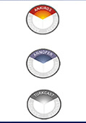
ANKIROS
International Iron-Steel & Foundry Technology,
Machinery and Products Trade Fair
www.ankiros.com
Istanbul 29-09.01.2016
ANNOVER
International Non-Ferrous Metals Technology,
Machinery and Products Trade Fair
www.ankiros.com
Istanbul 29-09.01.2016
TÜRKCAST
Foundry Producs Trade Fair
www.ankiros.com
Istanbul 29-09.01.2016

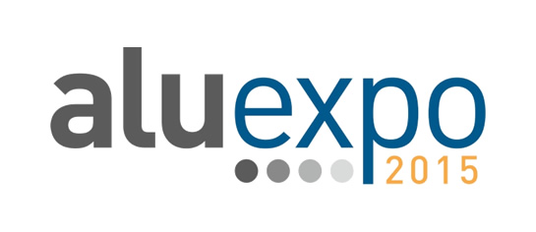
ALUEXPO
Aluminium Technologies, Machinery and Products Trade Fair
www.aluexpo.com
Istanbul 08-11.04.2015

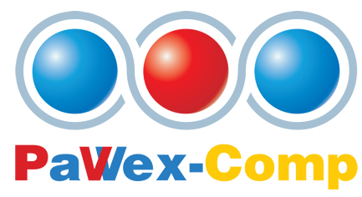
PaWex-Comp
Pumps, Valves, Water Treatment Systems Exhibiton
www.pawex.net

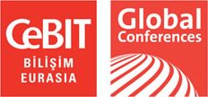
CeBIT Bilisim Eurasia
International Trade Fair for Information Technologies, Telecommunications, Software and Services, Satellite Communication, Broadcasting and TV Content
www.cebitbilisim.com
Istanbul 13-15.10.2016

